**Resume Addition**

The title of my M.S. research and thesis is “Identification and Resolution of Interpenetration Regions of Composite Fiber Bundle Surface Meshes using Different Data Representation Types” and is focused on identifying surface meshes that interpenetrate and resolving them. While at AFRL, I was introduced to the software that produces woven textile composites (or fabric-type composites) surface meshes and began working towards a solution to solving the issue of interpenetrations between the result of the software. During my time at Texas A&M, I continued this work until it developed into a Master’s level contribution and am currently in the finishing stages of research.

I have also attached a figure below that briefly illustrates the stages that the software I am using (called VTMS) goes through to create surface meshes.

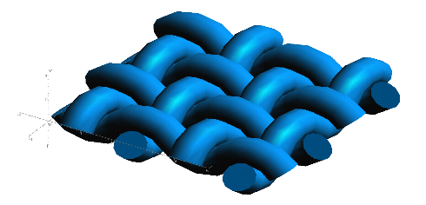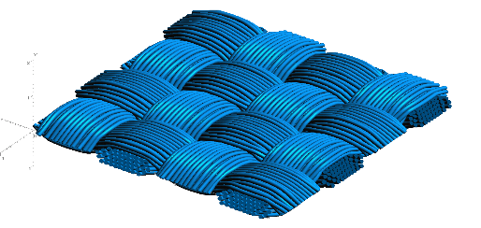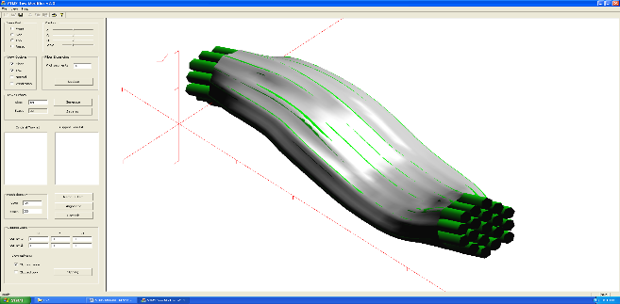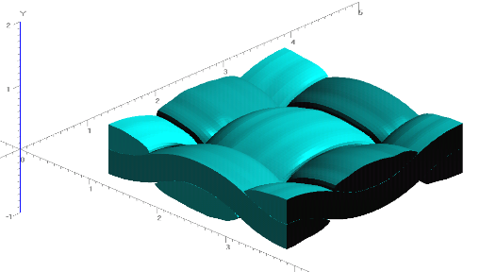

**Figure 1: Evolution of Weave Tow Geometry**

**a) Generic Approximation of Woven Pattern**

**b) Filament Representation of Pattern**

**c) Surface Approximation of Filament Bundles**

**d) Volume Model Derived from Surfaces**

The filaments are considered to be made up of many fibers each. This is to reduce the computational cost of creating the models. My research used the result of VTMS, shown in Fig 1.d.